**SD03Q011 – Problem Statement 1**

Balamanikandan V

1832012

**Problem Statement:**

Do an Exploratory data analysis on the given data sets (country-wise-average.csv and malnutrition-estimates.csv) without using any in build packages and give insights from the data and plot the analysis which you done.

**Dataset:**

Given 2 data sets (country-wise-average.csv and malnutrition-estimates.csv). In which country-wise-average.csv consists of 8 columns and 152 rows, and malnutrition-estimates.csv consists of 20 columns and 922 rows.

**Data Preprocessing:**

The Data is preprocessed by checking null values. The null values were replaced with 0.

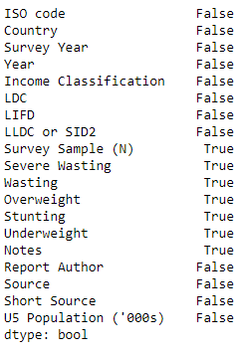

**Exploratory data analysis:**

Summarizing the datasets and giving a brief information about the datasets

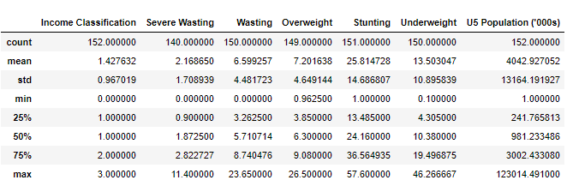

*Country wise average dataset*

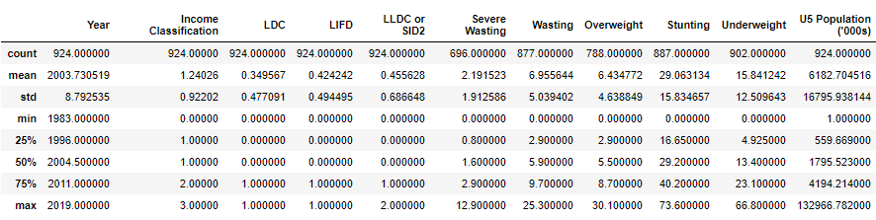

*Malnutrition estimates dataset*

**Malnutrition across different income group:**

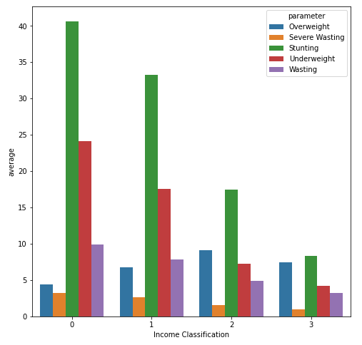

'Stunting ' and 'Underweight %' is very high in LOW and LOWER MIDDLE income countries. And 'Overweight %' is higher in UPPER MIDDLE and HIGH income countries. 'Wasting ' and 'Severe Wasting %' is also higher in LOW and LOWER MIDDLE income countries. Hence, LOW and LOWER MIDDLE income countries are the ones which are most affected by malnutrition.

**Analysis of countries which are both LDC and LIFD:**

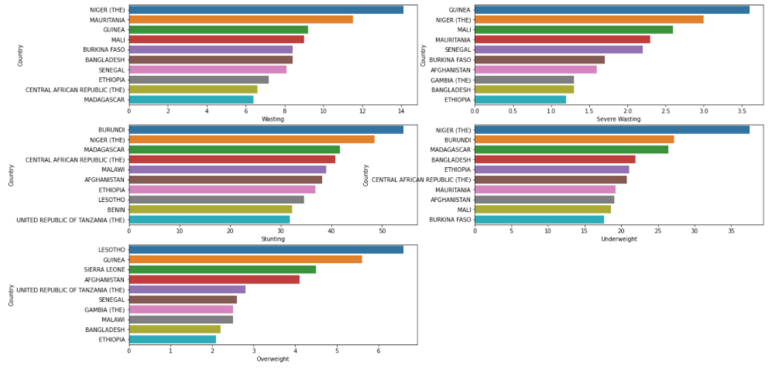

Niger, Ethiopia, Afganistan, Mauritania, Guinea, Mali, Burkina Faso, Bangaldesh, Senegal, Central African Republic, Madagascar are countries which are most affected from malnutrition.

**Malnutrition in LLDCs and SIDSs:**

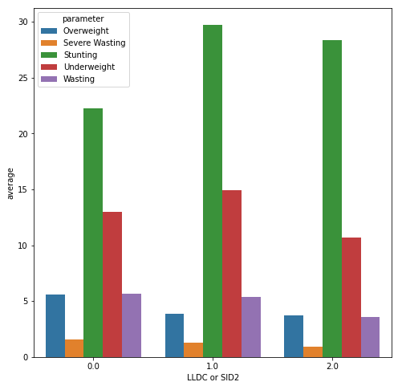

LLDC countries have a higher percentage of 'Stunting' undernutrition (about 30% of the children suffer from 'Stunting'). 'Severe Wasting ' and 'Overweight ' are very less in LLDC countries. About 16% children are 'Underweighted’.

**Countries which are very less affected from malnutrition:**

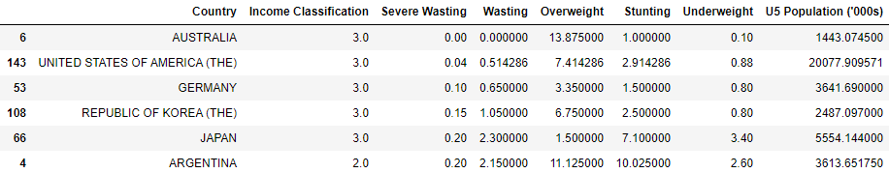

**Most malnourished countries:**

